

TIC TAC TOE GAME

BY: -

Rayyan Ahmed(21k-3079)

Shaikh Abdul Rafay(21k-3051)

Ayan Bin Rizwan(21k-3058)

ABOUT PROJECT

In this project we implemented the classic tic tac toe game with GUI in java using Java Swing and used multiple Data Structures concepts in it like 2d arrays, Recursion, Stacks, and backtracking. The IDE which is used to build this project is NetBeans

ABOUT GAME

Tic-tac-toe, Xs and Os is a paper-and-pencil game for two players who take turns marking the spaces in a three-by-three grid with X or O. The player who succeeds in placing three of their marks in a horizontal, vertical, or diagonal row is the winner. In this project all the rules are same except here, only one user can play at a time against the machine or bot. User will be prompted to make his/her move and then bot will make its move, and this will go back and forth until game reaches its conclusion

We implemented the game on two difficulties I.e., Easy and Hard

INTRO



In intro, user will be asked to choose a difficulty of his/her choice

EASY

In easy difficulty the bot is designed to pick a random position and place its marker over there irrespective of the opponent's move. This way user has a higher probability of

winning the game

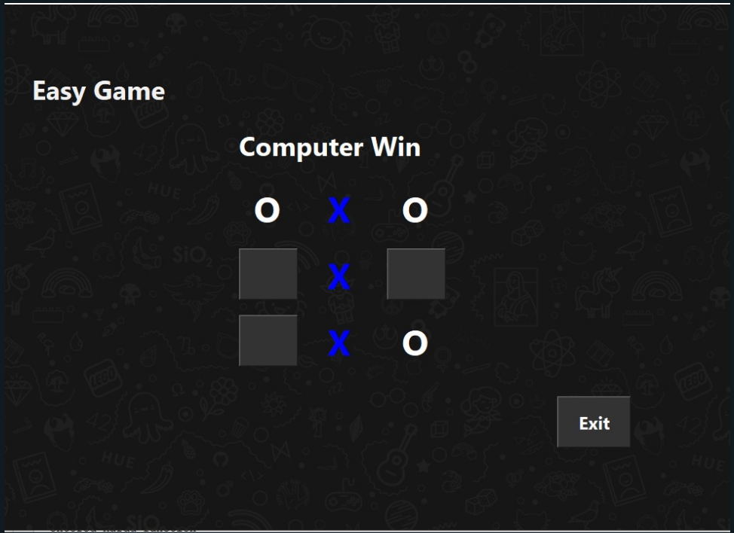

HARD

In hard difficulty the bot will make its move with respect to the user move so it will generate its move on the assumption that user is playing an optimal game of tic tac toe game so it's impossible for a user to win against bot in hard mode

Draw between user and bot

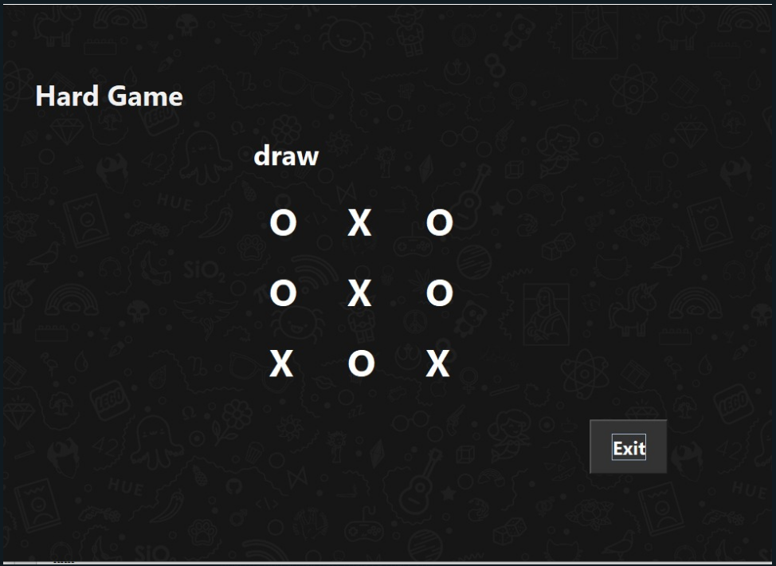

Bot winning the game

